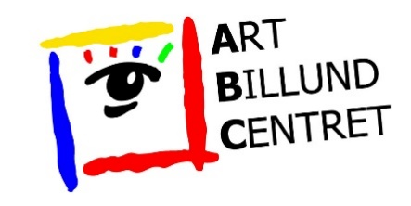
Application for participation in Art Billund Centret 2024 (deadline March 31st 2024)

Name:

Address:

Phone:

E-mail:

Website:

Facebook:
Items on display:
(State type of preferred material, such as paintings, ceramics, wood, photographs etc.)

My request:
 | Width | Depth | Height | Rate in DKK | Amount
Standsize Small  (2 led spots incl.) | 2,6 meter | 1,3 m | 2,30 m | 1.150
Standsize Large  (3 led spots incl.) | 3,9 meter | 1,3 m | 2,30 m | 1.450
Floor space  (Only 1 stand available)  (2 led spots incl.) | Open floor space (Ø 2.0 to 2.5 m.).  Suited for artworks on podiums etc. |  |  | 1.150
Membership fee 2024 for Billund Kunstforening  (if not paid already) | Mandatory membership fee 2024  (if not paid already) |  |  | 200 | 200
Price in total | - | - | - | Kr.

Please send this application form, or just an e-mail with your request, to art@billundkunstforening.dk no later than March 31st, 2024.

You don't have to pay any amount now.
In April/May 2024 you will receive our confirmation of whether you have been selected for exhibitor or not. If selected, we will charge you the total fee and ask you to send in the required portrait, text and sample photos.

